

TITLE: AI-BASED DISEASE PREDICTION USING BLOOD SAMPLES.

GROUP MEMBER:
AIZA SAQIB 70147247
MAILA SALEEM 70146709
AYESHA TARIQ 70151037
TANZEEL AHMAD 70147283

SUBMITTED TO: SIR SYED HAMEDON

DESCRIPTION:
This project focuses on building an AI-based disease prediction system using patient’s blood test data. The goal is to predict possible diseases accurately and fairly, even when some diseases appear less frequently in the dataset. To achieve this, a Balanced Random Forest model is used. Unlike traditional machine-learning models that tend to favor common diseases, this model treats all diseases equally, improving predictions for rare and critical conditions. The system is carefully designed to avoid data leakage, control overfitting, and evaluate performance on completely unseen test data, ensuring that it behaves reliably in real-world medical scenarios.
Beyond just the AI model, the project includes a fully functional backend and frontend, making the system interactive and user-friendly. Patients can input blood test values through the frontend, which communicates with the backend to process the data, run predictions, and return results in real time.
The final system not only predicts diseases but also:
- Shows model accuracy
- Displays a confusion matrix

FLOW DIAGRAM: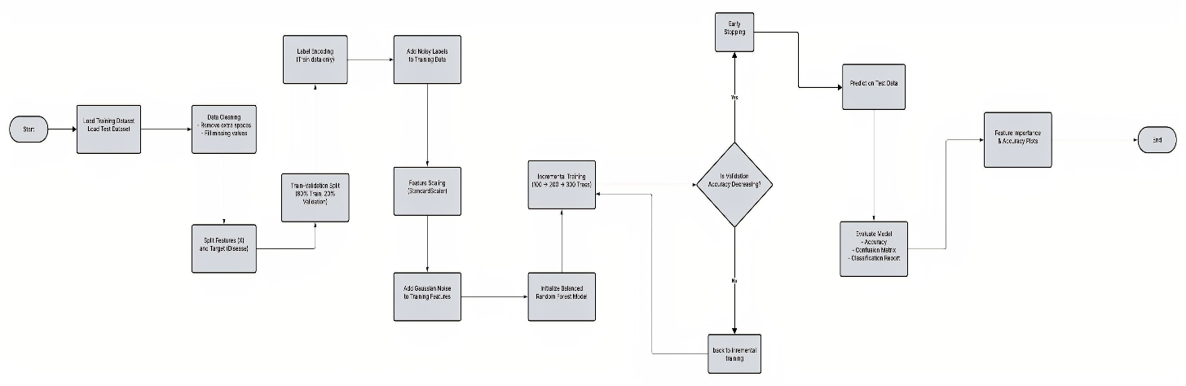

CODE:

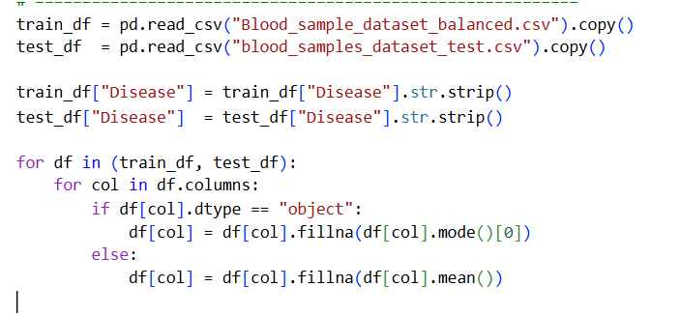
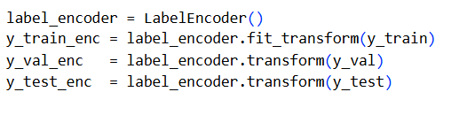

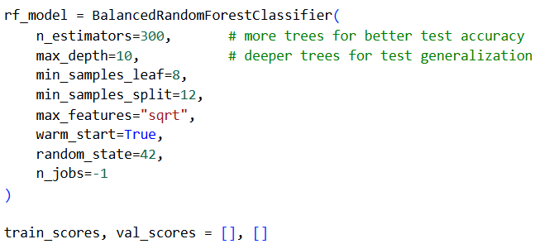
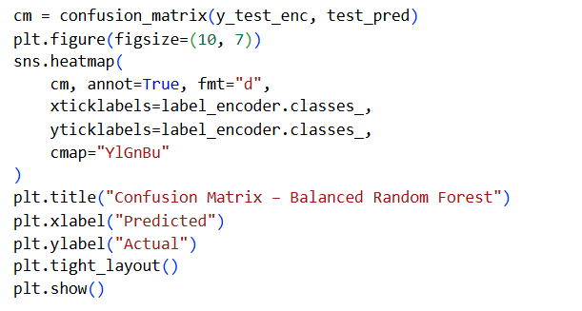
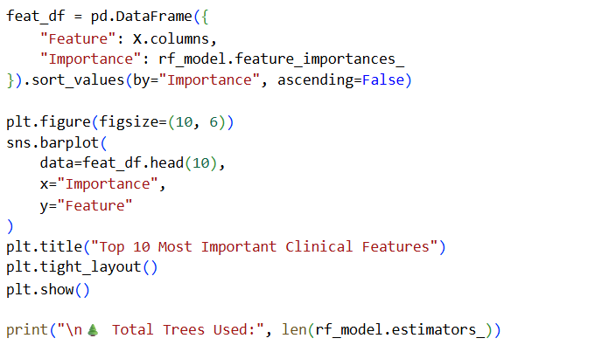
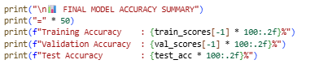

OUTPUT:
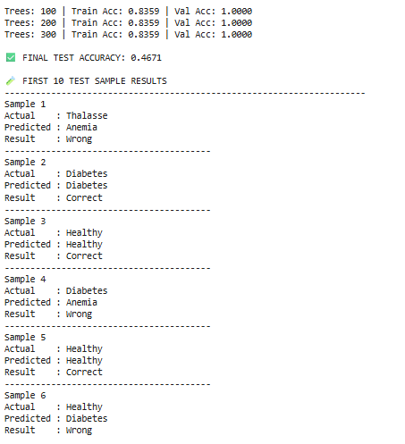
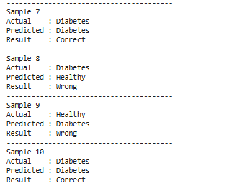
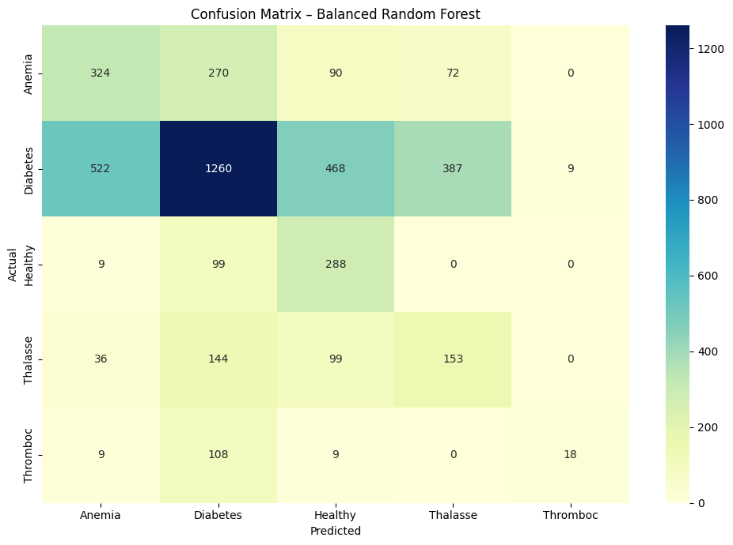
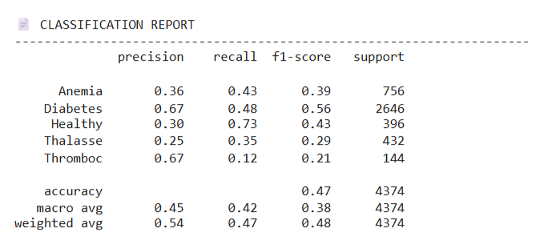
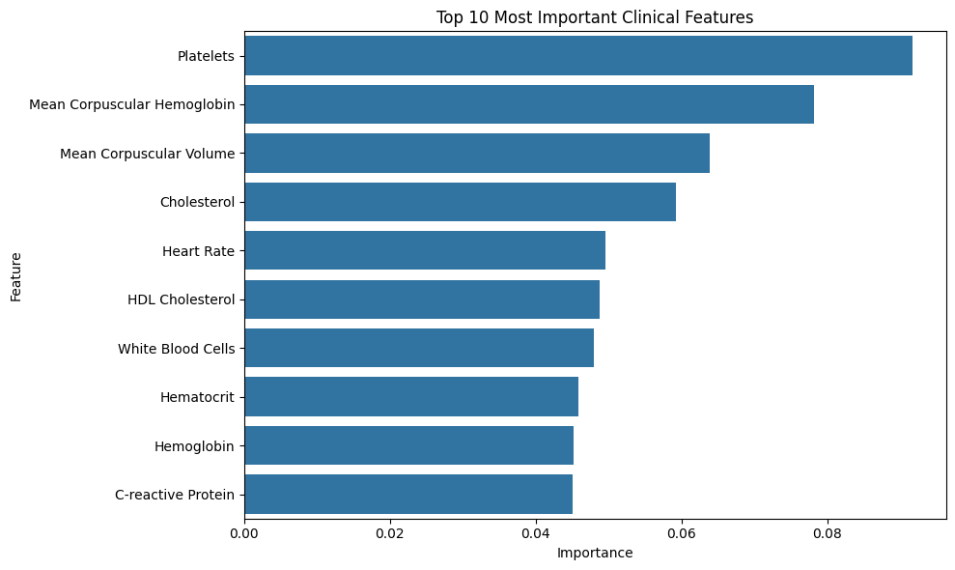
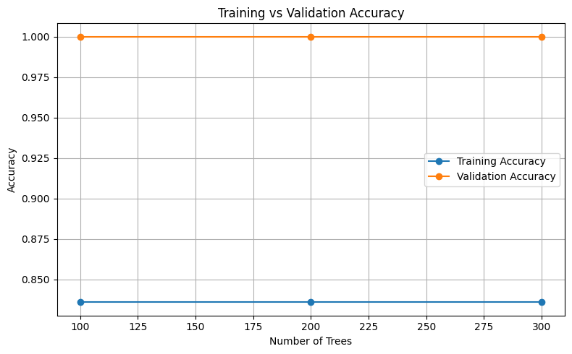
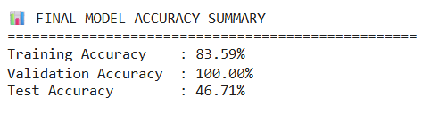
USER INTERFACE:
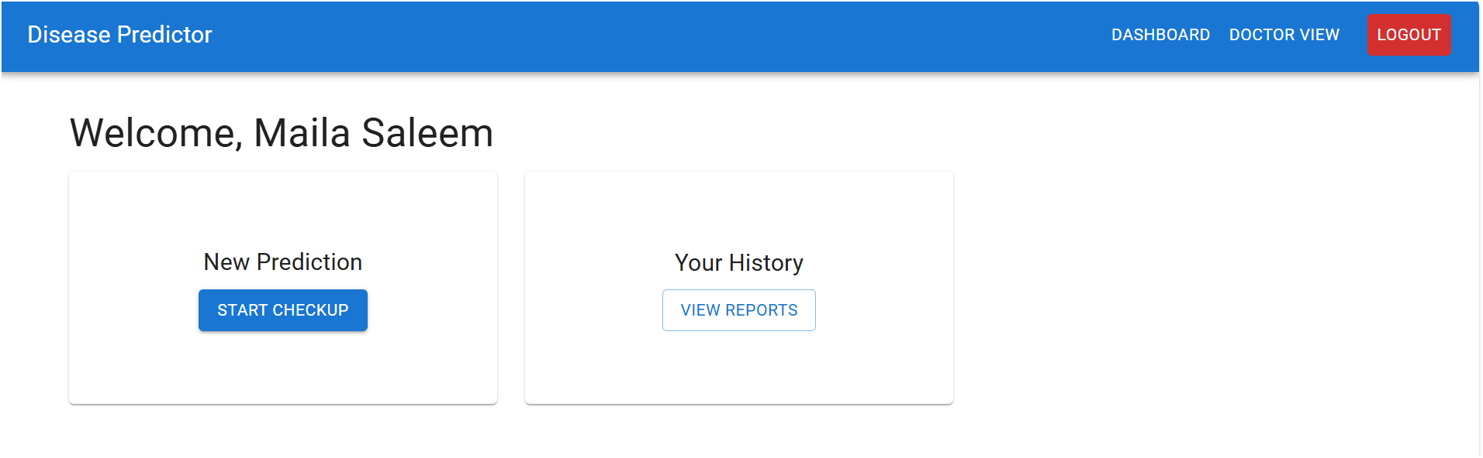
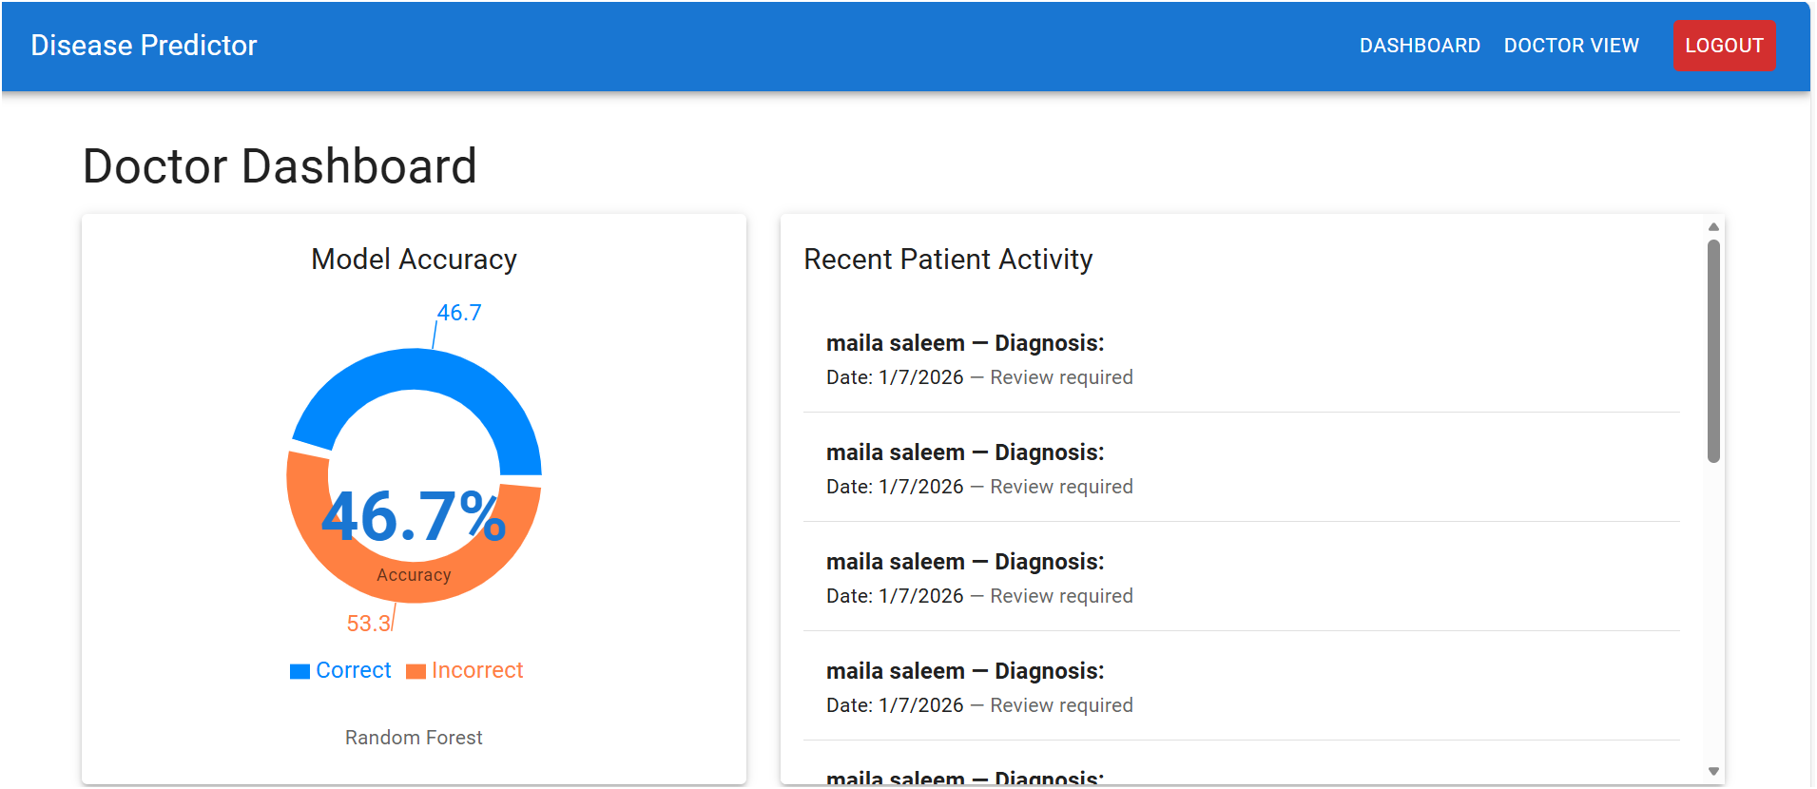

SCOPE:
- Dataset cleaning and preprocessing
- Handling missing values properly
- Implementing leakage-safe scaling
- Label encoding without test contamination
- Applying noise injection to avoid overfitting
- Training Balanced Random Forest model
- Incremental tree training with early stopping
- Model evaluation on validation and test data
- Visualization of results
- Feature importance analysis
Git repository:
https://github.com/aizasaqib/AI-PROJECT.git

